For my portfolio I decided to learn HTML and CSS, if a portfolio is designed to show off my work, why not make the portfolio itself an example of that skill.

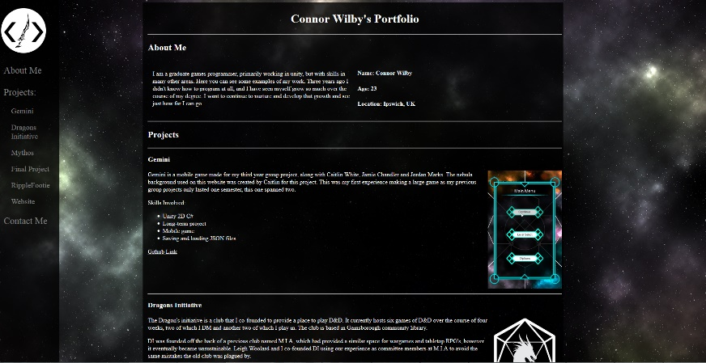

To that end, I tried to create a webpage that would immediately capture a reader’s interest. One of the first things the reader notices is a gif of one of my projects. This is accomplished by the movement of the gif itself. From there the reader may note that the background of the game is similar to the one used in the website. I have made a conscious effort to avoid using stock images/photos on this website, and I point out that “The nebula background used on this website was created by Caitlin for this project.” This would hopefully make the reader look at the website as a whole, noticing the sidebar, the custom logo and the other projects. The reader would then be drawn to the “about me” section of the page, at the very top, if they haven’t already. I have tried to include all six of the things listed in the article “6 Things You Should Put on Your Personal Website—and 6 Things to Avoid at All Costs”(Greenawald, 2018). I also took inspiration from the interactive resume of “Pascal van Gemert” (Gemert, 2018) as it is often cited as a good example, and I liked the layout.

I decided to include the following projects in my website:

* Gemini
* Dragon’s Initiative
* Mythos App
* Final Project
* RippleFootie
* Website
* Random Book Generator

Each of these projects was chosen because I am proud of it, and I think it shows off some of the skills I have. I have also listed a link to the Git repository where the project is stored if possible, allowing an employer to see the code I have created (after all, that’s what they would be hiring me for) and, in the case of my final project, my blog.

The Dragon’s Initiative is a club I co-founded and it shows off a number of skills that most of my other projects would not. It shows that I have leadership and organisational qualities, and the fact that I frequently DM for it shows that I have creative talent and some idea of game design principles. In addition, the logo I created for it (and the personal logo I created for myself) shows some artistic talent, though that is about the extent of my abilities.

Mythos is there to show that I can work with professionals outside of a learning environment and that my talents extend outside of games to a wider variety of programs. It is also a solo project, which shows other skills, such as self management abilities. When the app is further along, I will add finished pictures to the website.

My Final Project shows me working in a 3D environment and using Unity’s navmesh, as well as using game AI. It shows that I can use even more of Unity’s features than just the 2D, UI and Physics.

With Ripplefootie I wanted to show a different type of game. Since the previous two games were primarily UI based, I wanted to show that I could create a more dynamic, physics based game. Since Ripplefootie is the only group project that I would consider a success, I decided to add that in, with a gif showing the action, and a link to the github page.

One of the 6 things I should not include in my website, is every project I have ever done. This means that I should keep the list short and sweet, every one showing off a different skillset if possible. Since I created the website (and the user has experienced all of it, if they have gotten this far) I decided to add in a very basic description of my website, emphasising the fact that I created the entire thing from scratch. I used about half of a tutorial (YouTube, 2018) to learn the basics of HTML, and from there expanded and searched whenever I needed something I didn’t already have. This included a sidebar (W3schools.com, 2018) which I then created a subsection for, to show off my various projects.

Finally, I decided to add in a personal project, with some aspirations for the future. This shows an additional skill (using the .net framework) and shows that I am interested in programming in my free time.

Overall, I am pretty happy with the way my website turned out. I learned a lot doing it, and it shows off all the skills I want it to show. I was happy to find out that you can freely host a website on GitHub as well, as that allows me to change anything I want easily, and to link the Git repository in the website itself.

Greenawald, E. (2018). *6 Things You Should Put on Your Personal Website—and 6 Things to Avoid at All Costs*. [online] Themuse.com. Available at: https://www.themuse.com/advice/6-things-you-should-put-on-your-personal-websiteand-6-things-to-avoid-at-all-costs [Accessed 21 Mar. 2018].

Gemert, P. (2018). *Pascal van Gemert - Web Developer - Interactive Resume*. [online] Pascalvangemert.nl. Available at: http://www.pascalvangemert.nl/ [Accessed 21 Mar. 2018].

YouTube. (2018). *HTML and CSS Tutorial for Beginners | The Ultimate guide to learning HTML and CSS*. [online] Available at: https://www.youtube.com/watch?v=y3UH2gAhwPI&index=3&list=WL&t=8478s [Accessed 21 Mar. 2018].

W3schools.com. (2018). *How To Create a Fixed Sidebar*. [online] Available at: https://www.w3schools.com/howto/howto_css_fixed_sidebar.asp [Accessed 21 Mar. 2018].